14.78: (Note that increasing corresponds to moving toward the back of the car.)
a) The mass of air in the volume element is 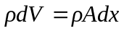, and the net force on the element in the forward direction is 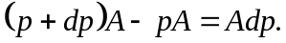From Newton’s second law, 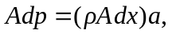 from which 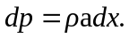 b) With given to be constant, and with 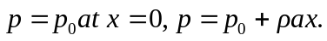 c) Using 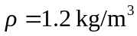in the result of part (b) gives , so the fractional pressure difference is negligble. d) Following the argument in Section 14-4, the force on the balloon must be the same as the force on the same volume of air; this force is the product of the mass 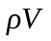and the acceleration, or 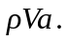 e) The acceleration of the balloon is the force found in part (d) divided by the mass 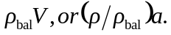 The acceleration relative to the car is the difference between this acceleration and the car’s acceleration, 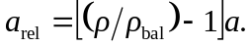 f) For a balloon filled with air, 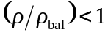 (air balloons tend to sink in still air), and so the quantity in square brackets in the result of part (e) is negative; the balloon moves to the back of the car. For a helium balloon, the quantity in square brackets is positive, and the balloon moves to the front of the car.

